币安参投、边玩边撸，如何玩转电子竞技平台Community Gaming？（附活动问题答案）

大家好，我是来自Coinmanlabs的Lisa，今天想跟大家聊聊币安参投的一个游戏平台。

### Community



项目官网：https://www.communitygaming.io/

项目推特：https://x.com/CommunityGaming.

项目介绍：Community Gaming 是一个一体化电子竞技比赛平台，为行业主要利益相关者提供尖端基础设施。其用户友好的界面和高度可扩展且高效的区块链支付技术为玩家、比赛组织者和游戏开发者提供了创建、促进和参与电子竞技比赛所需的工具。

投资机构：

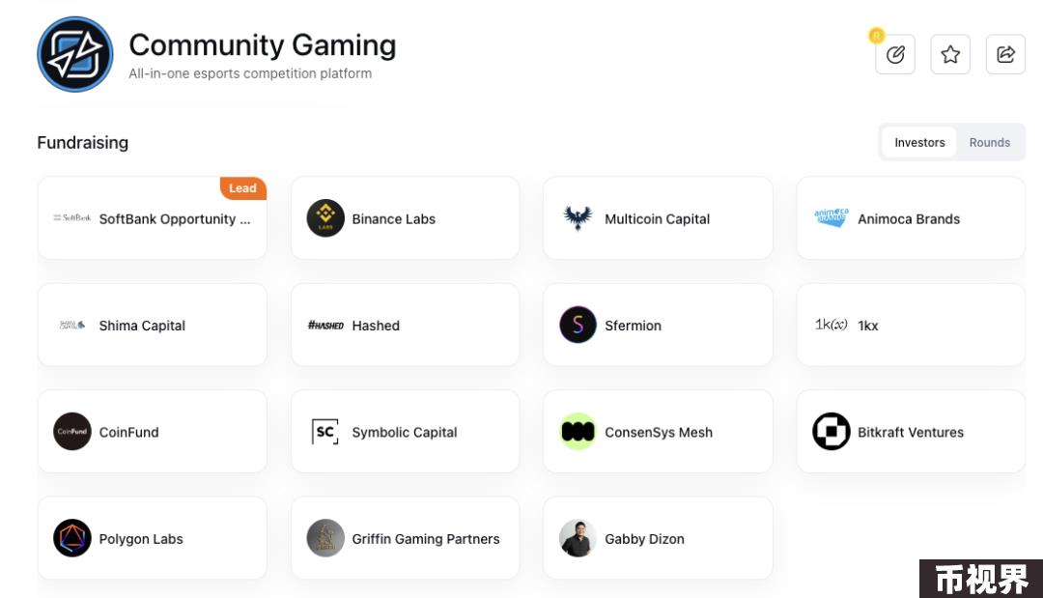

#### Q·目前可以做什么？

目前项目有夏日积分活动，明确会有奖励，具体的奖励需要等项目正式公布。

### 参与步骤

#### STEP.1注册账号

首先我们访问 https://communitygaming.io/auth?ref=coinmanlabs，进行账号的注册，可以使用邮箱、推特、Dsicord注册。

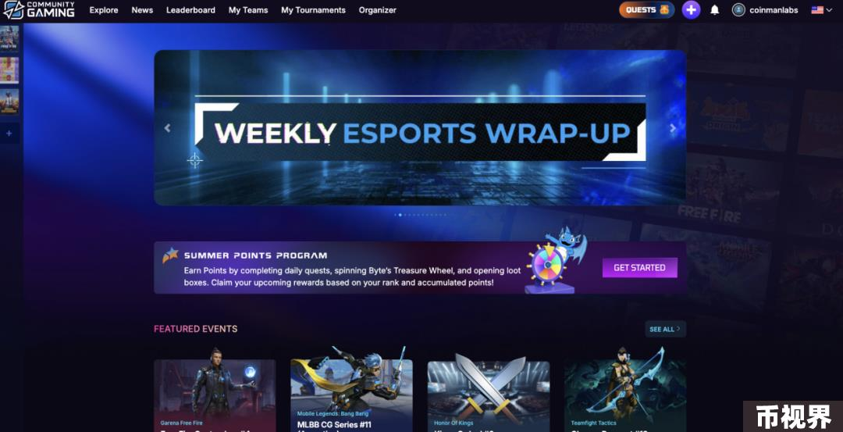

#### STEP.2完成任务

我们去到 https://www.communitygaming.io/quests，或者点击右上见的QUESTS来到每日任务处，别忘记点击每日转盘哦，转盘是24小时更新一次。

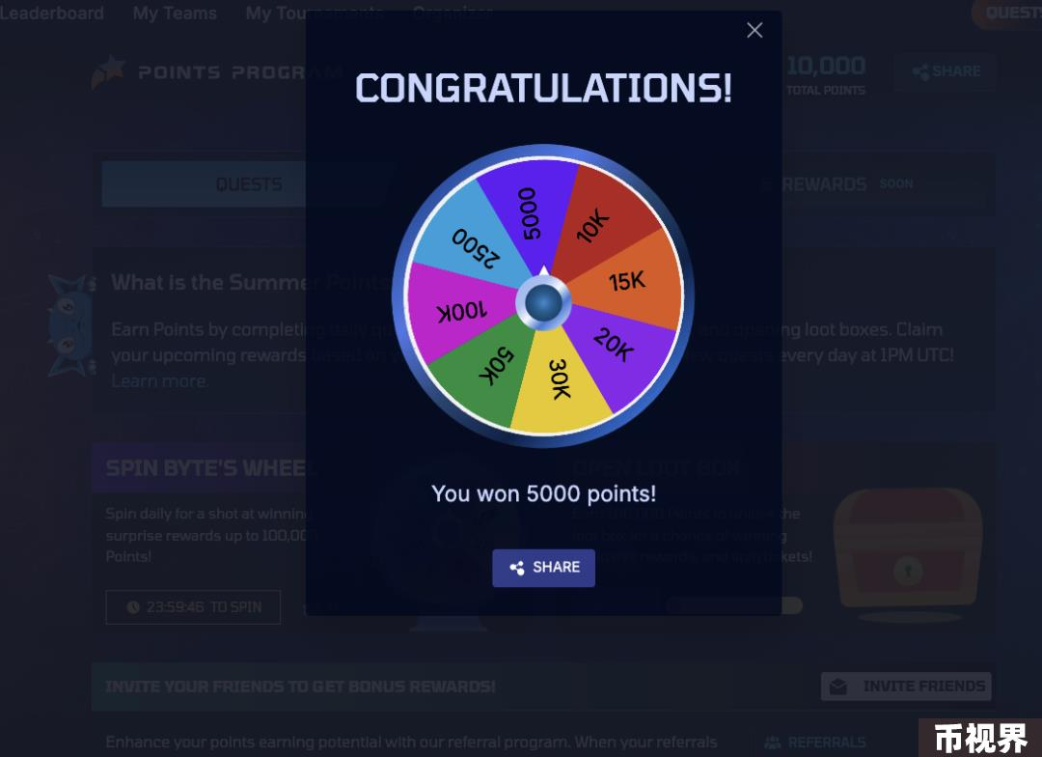

我们去到控制台绑定自己的推特等信息，也可以获得积分。

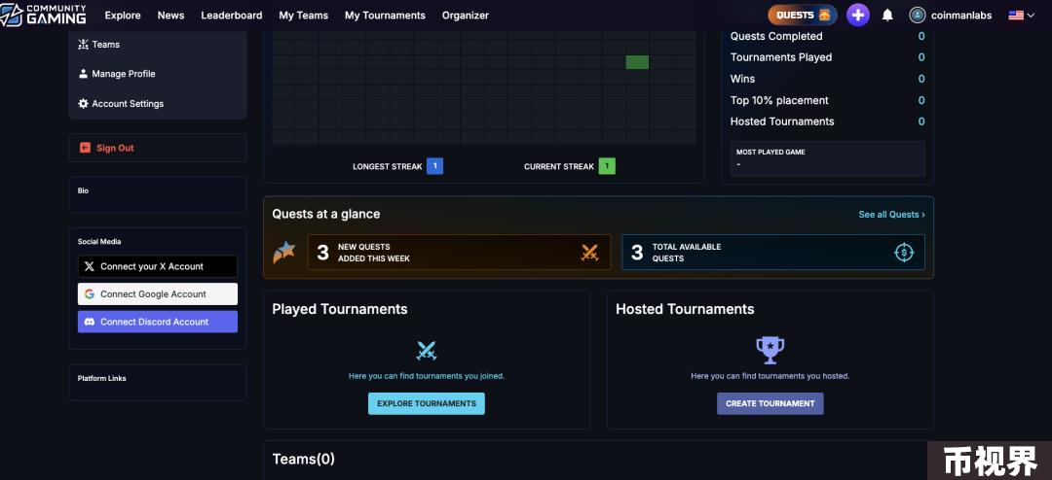

当你绑定完成后则可以看到任务的列表，我们按照完成即可。

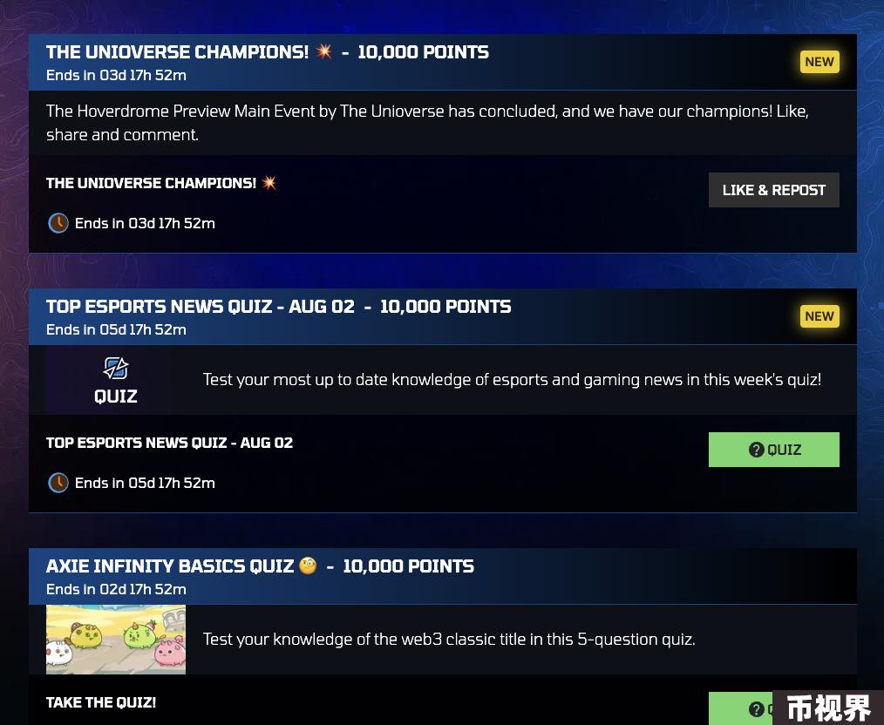

### 题目答案

该项目已获得大量资金，尚未大力推广，因此我们处于早期阶段。

FUN FACTS QUIZ FOR WEB3

What does DAO stand for?答案：Decentralized Autonomous Organization

What's another term used for Web3?答案：Semantic Web

Which pet-breeding game is considered the first web3 game to gain popularity?答案：CryptoKitties

This classic thrash metal band has issued their own non-fungible token collection？答案：Megadeth

Which of the following is the oldest cryptocurrency exchange?答案：Bitcoin Market

AXIE INFINITY BASICS QUIZ

The two tokens of Axie Infinity are Axie Infinity Shard (AXS) and SLP, which stands for this.答案：Small Love Potion

Which of the following is NOT an Axie class?答案：Dragon

What new feature is Axie Infinity introducing this summer?答案：Homeland Avatar Mode

What is the Axie Infinity universe called?答案：Lunacia

How many classes of Axies currently exist in Axie Infinity?答案：9

TOP ESPORTS NEWS QUIZ - AUG 02

Japan's Crazy Raccoon beat this team for the Overwatch 2 Esports World Cup title答案：Toronto Ultra

Where is the current S-tier VALORANT championship taking place?答案：Seoul

This team recently won the LEC Summer Playoffs答案：G2 esports

THE ULTIMATE LEGEND OF ZELDA QUIZ

The first Legend of Zelda game debuted in what year?答案：1985

Which was the first Zelda game to feature 3D graphics?答案：Ocarina of Time

The Triforce is separated into what three parts?答案：Power, Courage, and Wisdom

In Breath of the Wild, how long did Link spend in the Resurrection Shrine?答案：100 years

"It's dangerous to go alone. Take this." What item is this sentence referring to?答案：A wooden sword

### CoinmanLabs思考

该项目之前签到积分很低，最近更新后签到几天就超过之前的一个月玩家的积分了，积分大量稀释了，所以大家需要注意。