WhoMadeWho, Da Capo to Headline AFTER 2049, Singapore&#x27;s Biggest Pre- Formula 1 Party

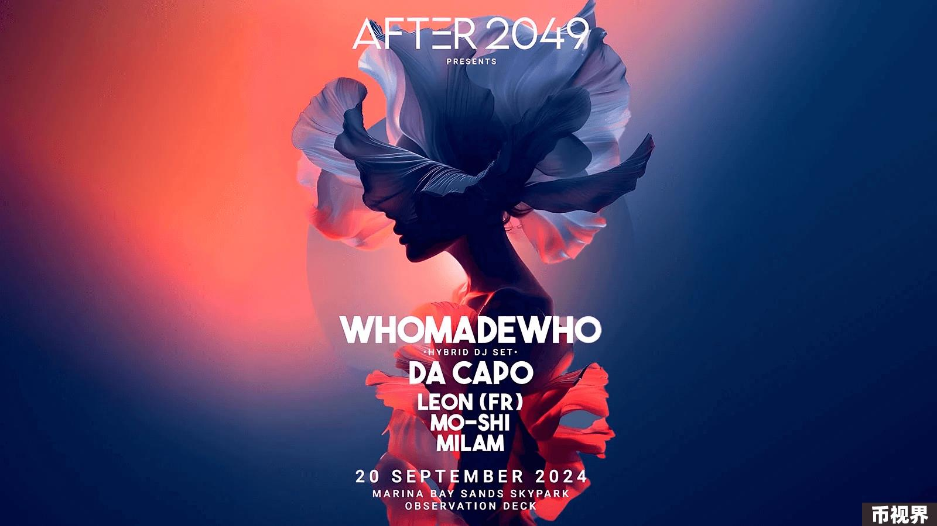

TOKEN2049, the world’s largest Web3 and crypto conference, announced a star-studded DJ line-up for AFTER 2049, the official closing event of this year’s highly anticipated Singapore edition. Making their eagerly awaited debut in Singapore, award-winning trio WhoMadeWhowill be headlining the event, alongside South African DJ and producer Da Capoand returning acts, Hong Kong’s Leon, Milamand Mo-Shi. AFTER 2049 will be held on Friday, 20th September at Marina Bay Sands’ SkyPark Observation Deck — open exclusively for AFTER 2049 each year, with exhilarating views of the Formula 1 evening session from the 57th floor.

This year’s AFTER 2049 will host 2,000 guests, with a premium open bar, and boasting a multi-sensory music experience with state-of-the-art productions, working with the best in the industry — details of which will be unravelled as the event nears. Tickets were sold out in minutes in 2023, with demand expected to surpass all previous records for the 2024 edition.

Having established themselves as one of the definitive electronic music acts of their generation, with performances at global music festivals like Burning Man, Sonar and Roskilde, WhoMadeWho will be bringing their unique music identity to AFTER 2049 and attendees can expect a scintillating hybrid DJ set.

Raphael Strauch, Founder of TOKEN2049said: “We're thrilled to bring AFTER 2049 back to the iconic Marina Bay Sands rooftop. This year, we've put together an incredible lineup featuring some of the largest names in electronic music. Our immersive setup will transform the venue into a portal of sound and light. Set against Singapore's mesmerising skyline, AFTER 2049 promises more than just music – it's a symphony of experiences where every element is crafted for an unforgettable night. Prepare for a landmark event that will redefine the electronic party scene in Singapore.”

Sponsors of AFTER 2049 include multichain real-world asset protocol Creditcoin, Incentive, decentralised talent incubator platform MEET48, chain abstraction stack NEAR, the distributed network for decentralised protocols 1inch, Axlflops, the platform combining blockchain with relational databases Chromia, the Bitcoin-powered, EVM-compatible blockchain Coredao, leading liquidity provider and digital asset exchange Darkex, the world’s first decentralised payments network Gnosis Pay, the application absolute liquidity network Haust, Hibachi, the security-first real-world asset layer-1 blockchain MANTRA, leading digital payment token service provider MetaComp, permissionless Ethereum Layer 2 network Metis, the permissionless liquidity layer for Web3 trading Orderly Network, the largest network of interconnected decentralised energy assets Rowan Energy and community foundation for Starknet’s permissionless decentralised Validity-RollupStarknet Foundation.

A limited number of tickets for AFTER 2049 will be sold via Resident Advisorfrom 13 August onwards, with additional ticket drops releasing 26 August and 12 September.

To purchase tickets for AFTER 2049, please visit: https://ra.co/events/1973782.

For more information and continued updates on TOKEN2049 Singapore, please visit: https://www.asia.token2049.com/. For any enquiries on AFTER 2049, please contact community@after2049.com.

###

#### About TOKEN2049

TOKEN2049 is a global Web3 event series, organised semi-annually in Singapore and Dubai, where decision-makers in the global crypto ecosystem connect to exchange ideas, network, and shape the industry. TOKEN2049 is the preeminent meeting place for entrepreneurs, institutions, industry insiders, investors, builders, and those with a strong interest in the crypto and blockchain industry.

Media Contact:

token2049@wachsman.com